Part of a moving wave

A wave moves forward through the water.
But how does each bit of water move?

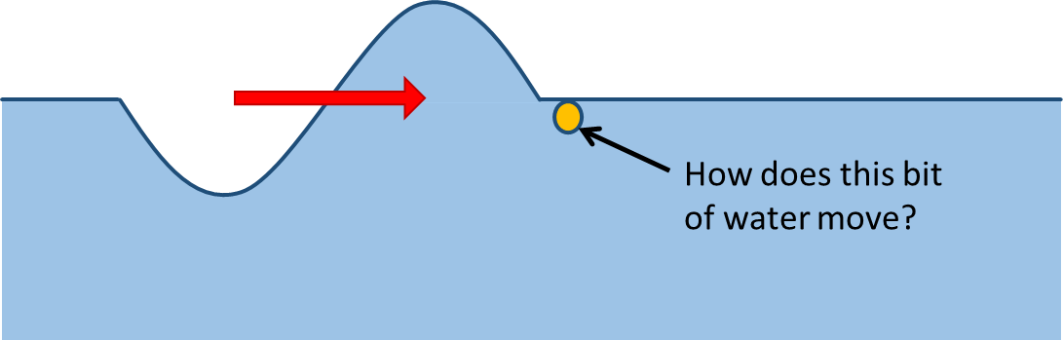

The yellow dot shows a bit of water in front of the wave.
The wave moves forward.
What do you think happens to this bit of water?
For each statement, tick (✓) one column to show what you think.
 |  | I am sure this is right | I think this is right | I think this is wrong | I am sure this is wrong
A | It moves up, then down and then up again.
B | It is pushed forward.
C | It first moves to go down under the dip.

Physics > Big idea PSL: Sound, light and waves > Topic PSL4: Waves > Key concept PSL4.1: Waves on water and ropes
Diagnostic question
Part of a moving wave

Overview
Learning focus: | A transverse wave travelling across the surface of water (or along a rope) transfers energy, as particles of water (or rope) are successively made to vibrate at right angles to the direction in which the wave travels.
Observable learning outcome: | Describe the movement of each ‘particle’ of a transverse wave as the wave moves forward.
Question type: | Confidence grid
Key words: | Wave

What does the research say?
When waves move through a medium students often describe the movement of some entity (perhaps mass, matter or force) through the medium. The scientific explanation involves no such movement. A wave moves forwards when a perturbation passes through a medium, and after it has passed the material of the medium returns to its original position. This is what distinguishes the motion of a wave from the motion of an object. (Fazio et al., 2008)
The motion of waves is hard for students to understand because waves form from large numbers of small scale events, such as the up and down movement of water particles in a water wave that are quite different to the form and motion of the wave (Caleon and Subramaniam, 2010). This is seen clearly when spectators in a sports stadium stand up and sit down in sequence to produce a Mexican wave moving around the stadium. In a mechanical wave the disturbance of one particle has a direct effect on the particles around it, causing them to move and progressively pass on the disturbance to adjoining particles. This process transfers energy through a medium, but without the transfer of any bulk substance.
Ways to use this question
Students should complete the confidence grid individually. This could be a pencil and paper exercise, or you could use an electronic ‘voting system’ or mini white boards and the PowerPoint presentation.
If there is a range of answers, you may choose to respond through structured class discussion. Ask one student to explain why they gave the answer they did; ask another student to explain why they agree with them; ask another to explain why they disagree, and so on. This sort of discussion gives students the opportunity to explore their thinking and for you to really understand their learning needs.
Differentiation
You may choose to read the questions to the class, so that everyone can focus on the science. In some situations it may be more appropriate for a teaching assistant to read for one or two students.
Expected answers
Statement A is correct
B and C are wrong
How to respond - what next?
As the wave passes the water particles move approximately up, then down and then up again. The dip following the crest in a water wave allows for the shift of water into the crest. This transfer of water makes water particles move in a somewhat circular up and down motion as they return to their original position. The net effect however is a movement up, down and then back up to where they started from that is described in answer A.
The part of wave indicated does not travel forwards (B wrong) and initially is moves up into the crest, as the crest passes. Students who think answer C is correct are likely to be thinking of the crest as a mass of water moving across the surface, which can move straight over the bit of water inticated.
If students have misunderstandings about the movement of each ‘particle’ of a transverse wave as a transverse wave moves forward, it can help to demonstrate to students what is actually happening. One way is to use a line of students to demonstrate a Mexican wave. This requires the students to start off seated. The student at one end stands up and sits down, whilst the student next to her/him does the same, but they stand only after they see the first student starting to rise up. This continues along the row so the wave moves forward but the students remain in place.
A second demonstration uses a rope or a ‘slinky spring’. The rope (or spring) is placed (or stretched) along a desk with a small piece of string tied half-way along its length. A sharp side-to-side movement of the hand, which is holding one end, sends a transverse wave along its length. Observing the piece of string shows that as the wave passes along the rope (or spring), each part moves only in a side-to-side direction.
The following BEST ‘response activities’ could be used in follow-up to this diagnostic question:
- Response activity: Making waves
- Response activity: Ripples on a pond
Acknowledgments
Developed by Peter Fairhurst (UYSEG).
Images: Peter Fairhurst (UYSEG).
References
Caleon, I. and Subramaniam, R. (2010). Development and Application of a Three-Tier Diagnostic Test to Assess Secondary Students' Understanding of Waves. International Journal of Science Education, 32:7, 939-961.
Fazio, C., et al. (2008). Modelling Mechanical Wave Propogation: Guidelines and experimentation of a teaching-learning sequence. International Journal of Science Education, 30:11, 1491-1530.

